DAILY ONLINE ACTIVITIES SUMMARY

|  |  |  |  |  |  |  |  |
| --- | --- | --- | --- | --- | --- | --- | --- |
| **Date:** | **29/05/2020** | | | | **Name:** | **Anusha** | |
| **Sem & Sec** | **8th- A** | | | | **USN:** | **4AL16CS014** | |
| Online Test Summary | | | | | | | |
| **Subject** | | **Big Data Analytics** | | | | | |
| **Max. Marks** | | **30** | | **Score** | | **22** | |
| Certification Course Summary | | | | | | | |
| **Course** | **Inttroduction to Hadoop** | | | | | | |
| **Certificate Provider** | | | **Great Learning Academy** | **Duration** | | | **5 hours** |
| Coding Challenges | | | | | | | |
| **Problem Statement:**  **1) Given an array arr[] of size N and an integer K. The task is to find the last remaining element in the array after reducing the array.** | | | | | | | |
| **Status: Executed** | | | | | | | |
| **Uploaded the report in Github** | | | | **Yes** | | | |
| **If yes Repository name** | | | | **anushasuvarna-014** | | | |
| **Uploaded the report in slack** | | | | **Yes** | | | |

Online Test Details:

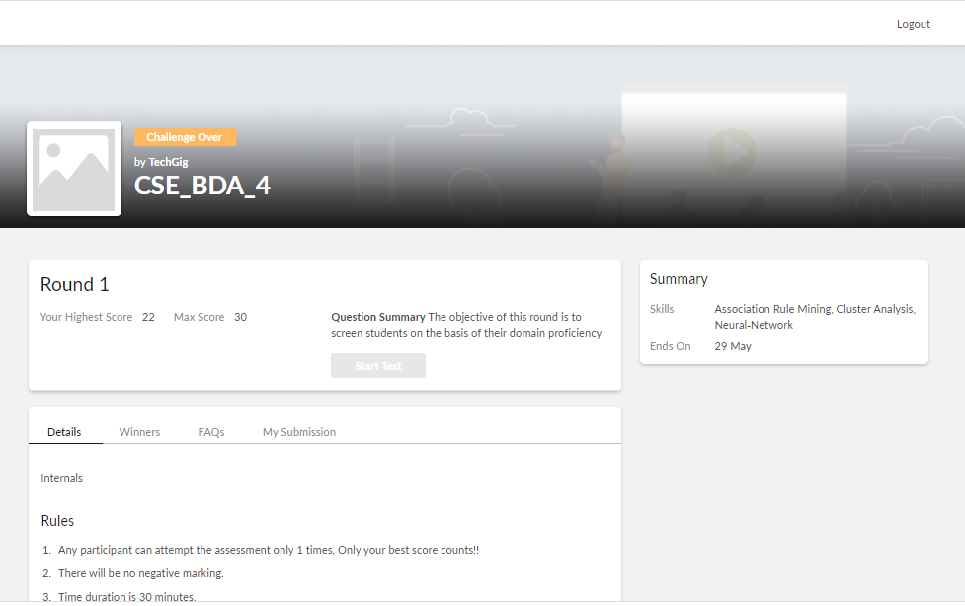

Certification Course Details:

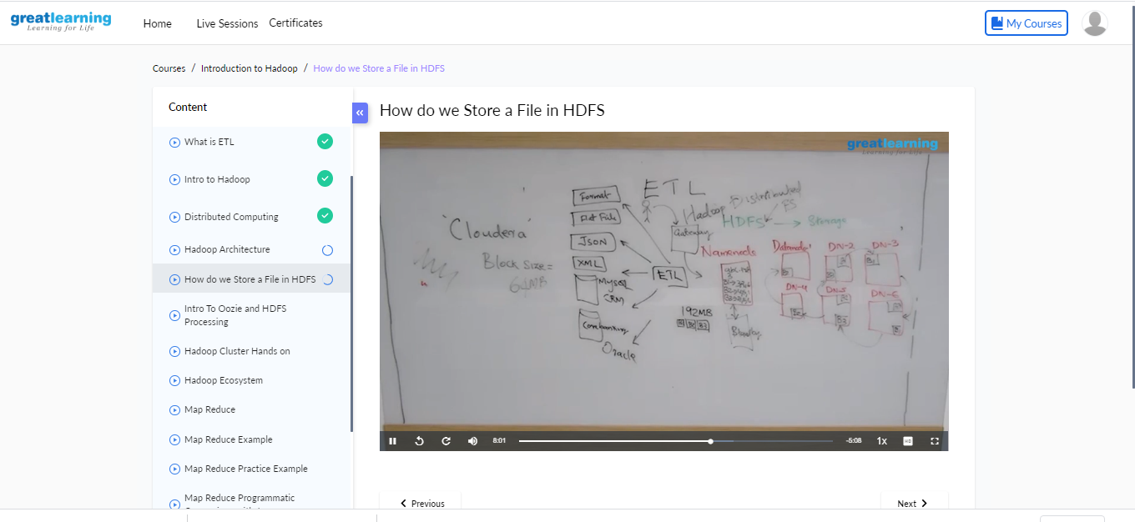

Coding Challenges Details:

void moreThanNdK(int arr[], int n, int k)

{

// k must be greater than 1 to get some output if (k < 2)

return;

/* Step 1: Create a temporary array (contains element and count) of size k-1. Initialize count of all elements as 0 */

struct eleCount temp[k-1]; for (int i=0; i<k-1; i++)

temp[i].c = 0;

/* Step 2: Process all elements of input array */ for (int i = 0; i < n; i++)

{

int j;

/* If arr[i] is already present in

the element count array, then increment its count */ for (j=0; j<k-1; j++)

{

if (temp[j].e == arr[i])

{

temp[j].c += 1; break;

}

}

/* If arr[i] is not present in temp[] */ if (j == k-1)

{

int l;

/* If there is position available in temp[], then place arr[i] in the first available position and set count as 1*/ for (l=0; l<k-1; l++)

{

if (temp[l].c == 0)

{

temp[l].e = arr[i]; temp[l].c = 1; break;

}

}

/* If all the position in the temp[] are filled, then decrease count of every element by 1 */

if (l == k-1)

for (l=0; l<k; l++) temp[l].c -= 1;

}

}

/*Step 3: Check actual counts of potential candidates in temp[]*/ for (int i=0; i<k-1; i++)

{

// Calculate actual count of elements int ac = 0; // actual count

for (int j=0; j<n; j++)

if (arr[j] == temp[i].e) ac++;

// If actual count is more than n/k, then print it if (ac > n/k)

cout << "Number:" << temp[i].e

<< " Count:" << ac << endl;

}

}